Shaik Sharifa Jahan

AP22110011103

1. Write an assembly language program to perform addition of 8-bit data.

org 100h

mov al, 02h

mov bl, 07h

add al, bl

add al, 30h

mov ah, 0Eh

int 10h

ret

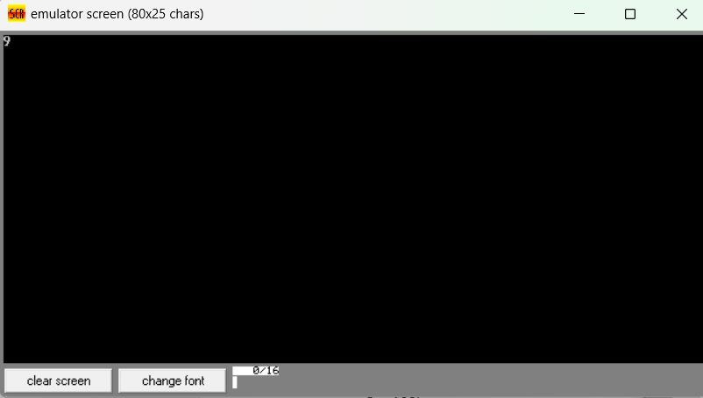

1. Write a program in assembly language to perform addition of 16-bit data.

org 100h

mov ax,2024h

mov bx,1929h

add ax,bx

ret

